**THE PEARL EXAMINATIONS 2024**

**TERM II QUALITY ASSURANCE**

**BABY CLASS: (3 – 4 YEARS)**

**LEARNING AREA 2: LANGUAGE DEVELOPMENT 1**

**My name is: ………………………………..………………..……………….**

**My School is: ……………………………..……….………………..………..**

**I am in: ………………………………..…………………………………………………..**

1. **Oral**
2. **What is your name?**
3. **Show me your eyes.**
4. **Show me your legs.**
5. **Clap your hands.**
6. **What is this?**

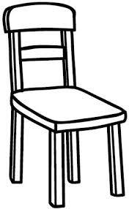

1. **What is this?**
2. **Who is your teacher?**
3. **Tell me your friend.**
4. **How old are you?**
5. **Why do you come to school?**
6. **Match things in class.**

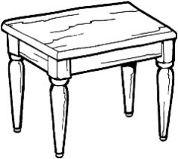 

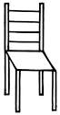 

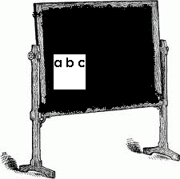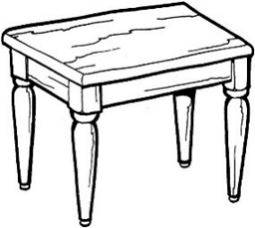

 

 

1. **Fill in the missing parts.**

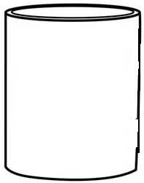 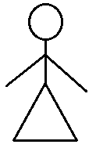

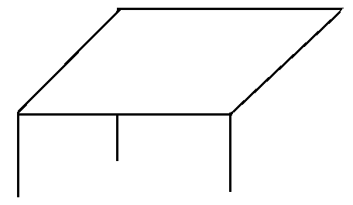 

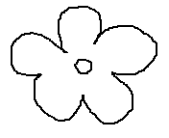

1. **Write over these letters.**

**END**